Prototyping User Interactions
Tyler Daniels
Southern New Hampshire University
CS-560
Professor Palmer
10-11-26

Prototyping User Interactions
The FitFlow fitness class booking prototype demonstrates a complete user flow through three connected screens: Available Classes, Class Details, and Booking Confirmation. The first screen allows users to browse four fitness classes and review important information such as class times, instructors, difficulty levels, and available spots (see Figure 1).
Figure 1
FitFlow Available Fitness Classes Screen
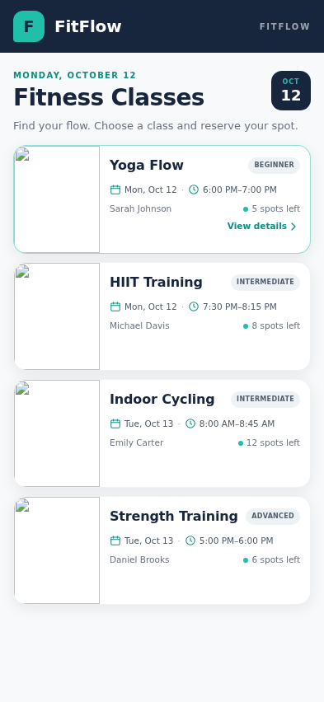
Note. The Available Classes screen displays four fitness classes with scheduling information, instructor names, difficulty levels, and available spots.
After selecting Yoga Flow, users are directed to the second screen, where they can review additional class details before making a reservation (see Figure 2).
Figure 2
FitFlow Yoga Flow Class Details Screen
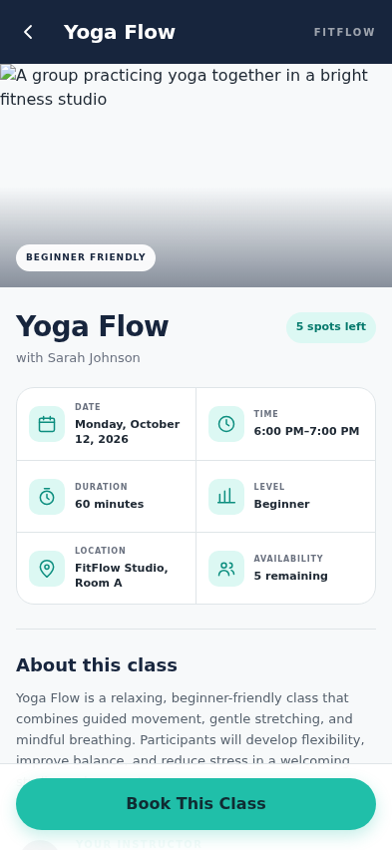
Note. The Class Details screen provides information about Yoga Flow, including the instructor, schedule, difficulty level, and availability, along with the option to book the class.
Selecting the "Book This Class" button takes users to the final screen, which confirms their booking and provides a summary of their reservation (see Figure 3).
Figure 3
FitFlow Booking Confirmation Screen
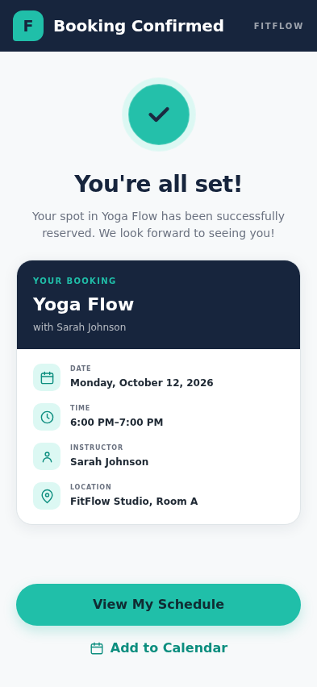
Note. The Booking Confirmation screen confirms a successful reservation and displays the selected class information and navigation options.
The prototype incorporates standardized Material Design 3 components, including navigation bars, cards, buttons, and icons, to maintain consistency throughout the application. Interactive connections between screens simulate a realistic booking process, while the back navigation and "View My Schedule" button allow users to move through the application without confusion. These features help create a straightforward and predictable experience.
Visual hierarchy also plays an important role in the prototype's usability. Bold headings, readable typography, consistent spacing, and clearly labeled buttons help users identify important information and actions. The teal accent color highlights interactive elements, while the navy headers and white backgrounds maintain a professional appearance. Additionally, the consistent layouts and touch-friendly controls support accessibility across all three screens. Overall, the prototype demonstrates how thoughtful interface design and standardized components can create a cohesive and user-friendly fitness class booking experience.

